WEEK 1
Clarifications about Upcoming Gated Recurrent Unit (GRU) Video
Correction in "Gated Recurrent Unit (GRU)" (14:04):
The last line should use an element-wise multiplication "*" instead of a plus sign "+".
$$c^{<t>}=Γ_{u}*{\tilde{c}}^{<t>}+(1-Γ_{u})*c^{<t − 1>}$$
See the correction in red.
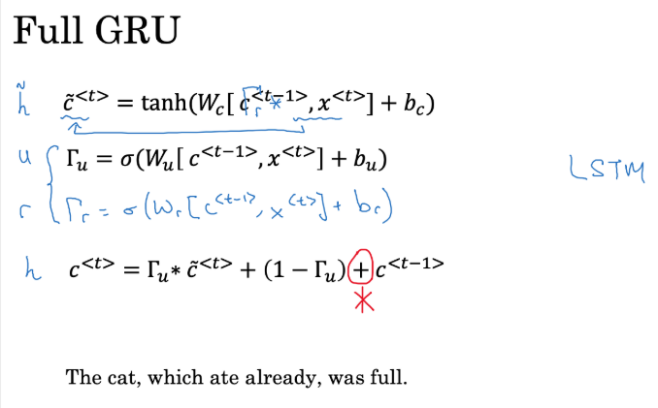

Clarifications about Upcoming Long Short Term Memory (LSTM) Video
0:12/0:12
Correction in "Long Short Term Memory (LSTM)" (4:10):
The last line should be:

$a^{<t>}=Γ_{o}*tanh(c^{<t>})$
See also the correction in the screenshot below (in red ink).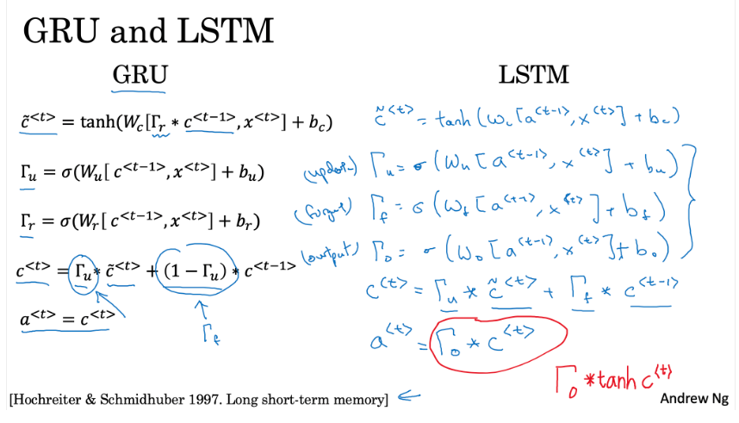

WEEK 1 QUIZ:
1.
Question 1
Suppose your training examples are sentences (sequences of words). Which of the following refers to the $s^{th}$ in the $r^{th}$, training example?
$$x^{<r>(s)}$$
$$x^{(s)<r>}$$
$$x^{(r)<s>}$$
$$x^{<s>(r)}$$
Try again
The parentheses represent the training example and the brackets represent the word. You should choose the training example and then the word.
0 / 1 point

Question 2
Consider this RNN:
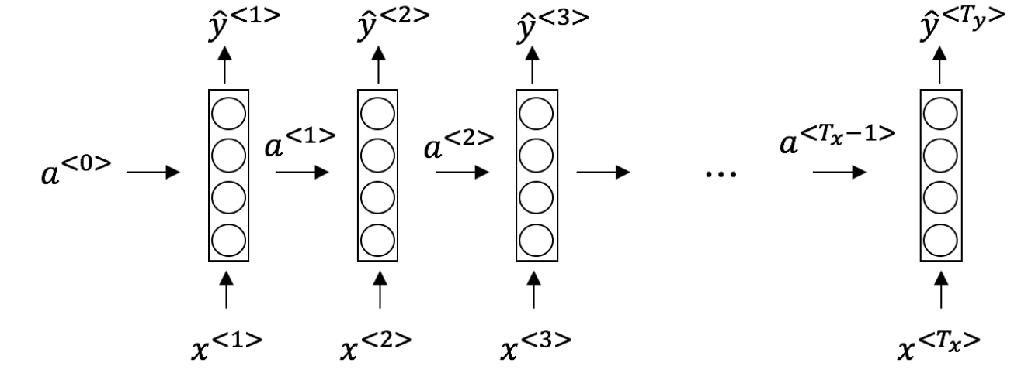
This specific type of architecture is appropriate when:
$$T_{x}=T_{y}$$
Question 3
Select the two tasks combination that could be addressed by a many-to-one RNN model architecture from the following:
Task 1: Gender recognition from audio. Task 2: Movie review (positive/negative) classification.
Question 4
Using this as the training model below, answer the following:
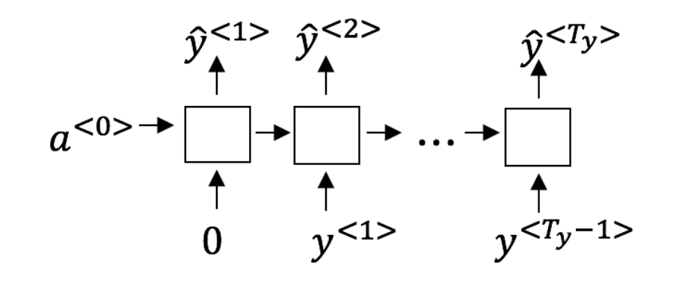
True/False: At the $t^{th}$ time step the RNN is estimating $P\left(y^{<t>}\right|y^{<1>},y^{<2>},…,y^{<t − 1>})$
True
Question 5
You have finished training a language model RNN and are using it to sample random sentences, as follows:
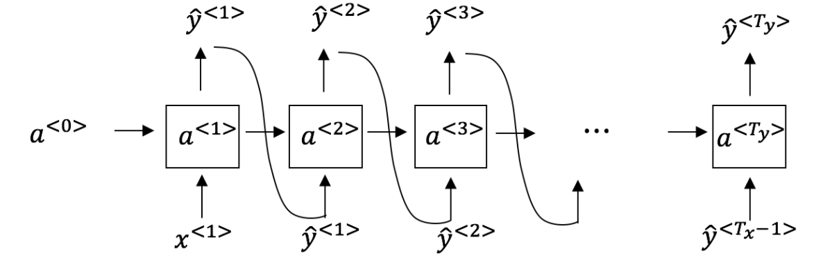
True/False: In this sample sentence, step t uses the probabilities output by the RNN to randomly sample a chosen word for that time-step. Then it passes this selected word to the next time-step.
True

Nice work
Step t uses the probabilities output by the RNN to randomly sample a chosen word for that time-step. Then it passes this selected word to the next time-step.

Question 6
True/False: If you are training an RNN model, and find that your weights and activations are all taking on the value of NaN (“Not a Number”) then you have an exploding gradient problem.
True

7.
Question 7
Suppose you are training an LSTM. You have an 80000 word vocabulary, and are using an LSTM with 800-dimensional activations $a^{<t>}$. What is the dimension of $Γ_{u}$ end subscript at each time step?
800
1 / 1 point
8.
Question 8
True/False: To simplify the GRU architecture while maintaining its ability to handle vanishing gradients and long-term dependencies, you should remove the update gate ($Γ_{u}$) and set $Γ_{u}=0$ equals, 0.
False
Nice work
Yes. You should not remove the update gate. The update gate defines whether the memory is refreshed or kept; without it, the model cannot control its memory state. The standard simplification for a GRU involves removing the relevance gate ($Γ_{r}$\Gamma, start subscript, r, end subscript), which simplifies the candidate calculation but leaves the memory-retention mechanism intact.
Question 9
Here are the equations for the GRU and the LSTM:
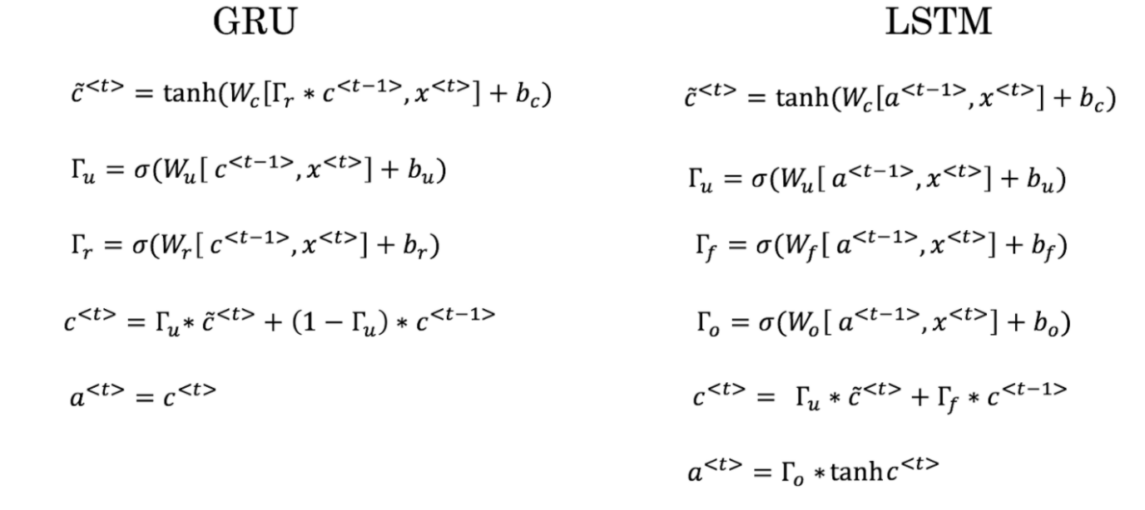
From these, we can see that the Update Gate and Forget Gate in the LSTM play a role similar to _______ and ______ in the GRU. What should go in the blanks?
$Γ_{u}$ and $1-Γ_{u}$
Question 10
Your mood is heavily dependent on the current and past few days’ weather. You’ve collected data for the past 365 days on the weather, which you represent as a sequence as $x^{<1>},…,x^{<365>}$. You’ve also collected data on your mood, which you represent as $y^{<1>},…,y^{<365>}$. You’d like to build a model to map from x→y. Should you use a Unidirectional RNN or Bidirectional RNN for this problem?
Unidirectional RNN, because the value of $y^{<t>}$ depends only on $x^{<1>},…,x^{<t>}$ but not on $x^{<1>},…,x^{<365>}$
Nice work

Week 2
Clarifications about Upcoming GloVe Word Vectors Video
1. Correction in "GloVe word vectors," slide 2 (1:14):
Xij is the number of times word j occurs in the context of word i.
Corrected slide:

2. Correction in "GloVe word vectors" slide 4 (8:11): 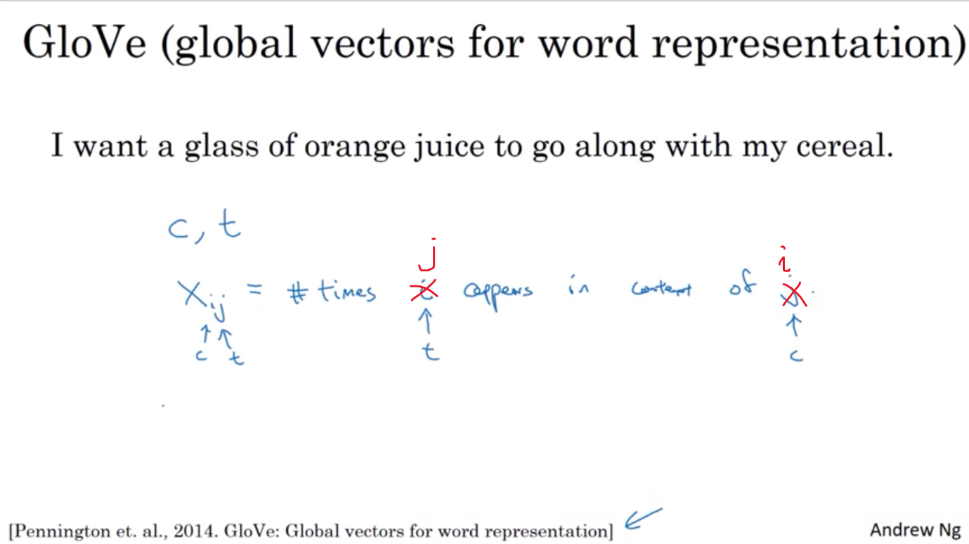
Week 2 Quiz:
Question 1
True/False: Suppose you learn a word embedding for a vocabulary of 60000 words. Then the embedding vectors could be 60000 dimensional, so as to capture the full range of variation and meaning in those words.
False

Nice work
No, the dimension of word vectors is usually smaller than the size of the vocabulary. Most common sizes for word vectors range between 50 and 1000.
1 / 1 point

Question 2
True/False: t-SNE is a linear transformation that allows us to solve analogies on word vectors.

False
Nice work
tr-SNE is a non-linear dimensionality reduction technique.
1 / 1 point

Question 3
Suppose you download a pre-trained word embedding which has been trained on a huge corpus of text. You then use this word embedding to train an RNN for a language task of recognizing if someone is happy from a short snippet of text, using a small training set.
x (input text) | y (happy?)
Having a great time! | 1
I'm sad it’s raining. | 0
I’m feeling awesome! | 1
Even if the word “wonderful” does not appear in your small training set, what label might be reasonably expected for the input text “I feel wonderful!”?
Do you understand?.
y=1

Nice work
Yes, word vectors empower your model with an incredible ability to generalize. The vector for “wonderful” would contain a negative/unhappy connotation which will probably make your model classify the sentence as a "1”.
1 / 1 point

Question 4
Which of these equations do you think should hold for a good word embedding? (Check all that apply)
$$e_{man}-e_{king}≈e_{woman}-e_{queen}$$
Nice work
The order of words is correct in this analogy.
$$e_{man}-e_{woman}≈e_{king}-e_{queen}$$
Nice work
The order of words is correct in this analogy.
1 / 1 point

Question 5
True/False: The most computationally efficient formula for Python to get the embedding of word 1021, if $C$C is an embedding matrix, and $o_{1021}$o, start subscript, 1021, end subscript is a one-hot vector corresponding to word 1021, is $C^{T}*o_{1021}$C, start superscript, T, end superscript, times, o, start subscript, 1021, end subscript.
False

Nice work
It is computationally wasteful because the element-wise multiplication will be extremely inefficient.
1 / 1 point

Question 6
When learning word embeddings, words are automatically generated along with the surrounding words.
False

Nice work
We pick a given word and try to predict its surrounding words or vice versa.
1 / 1 point

Question 7
In the word2vec algorithm, you estimate $P(t∣c)$, where $t$ is the target word and $c$ is a context word. How are $t$ and $c$ chosen from the training set? Pick the best answer.
$c$ and $t$ are chosen to be nearby words.
Nice work
1 / 1 point

Question 8
Suppose you have a 10000 word vocabulary, and are learning 100-dimensional word embeddings. The word2vec model uses the following softmax function:
$$P(t ∣ c)=\frac{e^{θ_{t}^{T}e_{C}}}{\sum_{t^{'}=1}^{10000}{e^{θ_{t}^{T}e_{C}}}}$$
Which of these statements are correct? Check all that apply.
$θ_{t}$ are both trained with an optimization algorithm.
Nice work
To review this concept watch the Word2Vec lecture.
$θ_{t}$ are both 100 dimensional vectors. Feedback: To review this concept watch the Word2Vec lecture.
Nice work
1 / 1 point

Question 9
Suppose you have a 10000 word vocabulary and are learning 500-dimensional word embeddings. The GloVe model minimizes this objective:
$$min⁡\sum_{i=1}^{10,000}{\sum_{j=1}^{10,000}{f(}}X_{ij})(θ_{i}^{T}e_{j}+b_{i}+b_{j}\text{’}-logX_{ij})^{2}$$
Which of these statements are correct? Check all that apply.
$θ_{i}$ and $e_{j}$ should be initialized randomly at the beginning of training.
Nice work
Theoretically, the weighting function $f(.)$ must satisfy $f(0)=0$.
Nice work
$X_{ij}$ is the number of times word j appears in the context of word i.
Nice work
Question 10
You have trained word embeddings using a text dataset of $s_{1}$s, start subscript, 1, end subscript words. You are considering using these word embeddings for a language task, for which you have a separate labeled dataset of $s_{2}$s, start subscript, 2, end subscript words. Keeping in mind that using word embeddings is a form of transfer learning, under which of these circumstances would you expect the word embeddings to be helpful?
$s_{1}$ >> $s_{2}$

Week 3:
Clarifications about Upcoming Attention Model Video:
At time 5:32, Andrew says "This network up here looks like a pretty standard RNN sequence with the context vectors as output". The correct wording should say that the context vectors are "inputs" to the post-attention RNN.

Week 3 QUIZ:
1.
Question 1
Consider using this encoder-decoder model for machine translation.
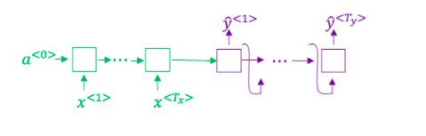
True/False: This model is a “conditional language model” in the sense that the decoder portion (shown in purple) is modeling the probability of the output sentence $y$ given the input sentence $x$.
True
Question 2
In beam search, if you increase the beam width B, which of the following would you expect to be true?
Beam search will generally find better solutions (i.e. do a better job maximizing P(y∣x)).
Nice work
As the beam width increases, beam search runs more slowly, uses up more memory, and converges after more steps, but generally finds better solutions.
Question 3
In machine translation, if we carry out beam search without using sentence normalization, the algorithm will tend to output overly short translations.
True
Question 4
Suppose you are building a speech recognition system, which uses an RNN model to map from audio clip $x$ to a text transcript $y$. Your algorithm uses beam search to try to find the value of $y$ that maximizes $P(y∣x)$.
On a dev set example, given an input audio clip, your algorithm outputs the transcript $\hat{y}=$ “I’m building an A Eye system in Silly con Valley.”, whereas a human gives a much superior transcript $y^{*}=$ “I’m building an AI system in Silicon Valley.”
According to your model,
$$P(\hat{y}∣x)=1.09*10^{-}7$$
$$P(y^{*}∣x)=7.21*10^{-}8$$
Would you expect increasing the beam width B to help correct this example?
Yes, because $P(y^{*}∣x)≤P(\hat{y}∣x)$ indicates the error should be attributed to the RNN rather than to the search algorithm.
No, because $P(y^{*}∣x)≤P(\hat{y}∣x)$ indicates the error should be attributed to the search algorithm rather than to the RNN.
Yes, because $P(y^{*}∣x)≤P(\hat{y}∣x)$ indicates the error should be attributed to the search algorithm rather than to the RNN.
No, because $P(y^{*}∣x)≤P(\hat{y}∣x)$ indicates the error should be attributed to the RNN rather than to the search algorithm.
Try again
0 / 1 point

Question 5
Suppose you are building a speech recognition system, which uses an RNN model to map from audio clip $x$ to a text transcript $y$. Your algorithm uses beam search to try to find the value of y that maximizes $P(y∣x)$.
Suppose you work on your algorithm for a few more weeks, and now find that for the vast majority of examples on which your algorithm makes a mistake, $P(y^{*}∣x)>P(\hat{y}∣x)$. This suggests you should focus your attention on improving the RNN.
False
Question 6
Consider the attention model for machine translation.
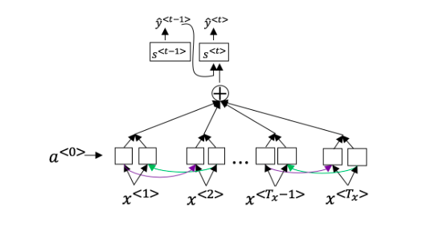
Further, here is the formula for $α^{<t , t\text{’}>}$
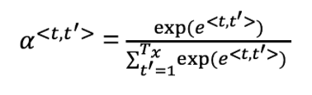
Which of the following statements about $α^{<t , t\text{’}>}$ are true? Check all that apply.
$α^{<t , t\text{’}>}$is equal to the amount of attention $y^{<t>}$ should pay to $a^{<t\text{’}>}$.
$\sum_{t\text{’}}{α^{<t , t\text{’}>}}=1$. (Note the summation is over t’.)

Question 7
The network learns where to “pay attention” by learning the values $e^{<t , t\text{’}>}$ which are computed using a small neural network:
We can't replace $s^{<t − 1>}$ with $s^{<t>}$ as an input to this neural network. This is because $s^{<t>}$ depends on $α^{<t , t\text{’}>}$ which in turn depends on $e^{<t , t\text{’}>}$ so at the time we need to evaluate this network, we haven’t computed $s^{<t>}$ yet.
True
Question 8
The attention mechanism was primarily introduced to solve the information bottleneck problem in standard encoder-decoder models. In which situation is this mechanism less critical for achieving good performance?
The input sequence length $T_{x}$, is small.

Question 9
Under the CTC model, identical repeated characters not separated by the “blank” character (_) are collapsed. Under the CTC model, what does the following string collapse to?
__c_oo_o_kk___b_ooooo__oo__kkk
cookbook

Question 10
In trigger word detection, if the target label for $x^{<t>}$x, start superscript, is less than, t, is greater than, end superscript is 1:
Someone has just finished saying the trigger word at time t.

Week 4:
Multi-Head Attention Correction:
Reflect
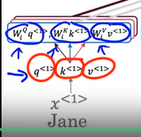
Note that in the previous video you learned that you calculate $q$, $k$ and $v$ (circled red) by multiplying $x$ with matrices $W$. In case of the multi-head attention, you don't need to do this, as you already have the matrices $W_{i}$ in each head, and you would effectively do the calculation twice if you did the multiplication here also. In the simplest case of multi-headed self-attention you would actually use $q=k=v=x$. The reason we anyway show $q$, $k$ and $v$ here as different values is that in one part of the transformer (where you calculate the attention between the input and output) the $q$, $k$ and $v$ are not all the same, as they carry different information as you will learn in the next video.

Reflect
Note that in the video every value of $i$ repeats twice. This is because you use each value of $i$ to encode two dimensions using the sine and cosine functions (same $i$ is used both for sine and cosine). To calculate $i$, you can use a helper index $k$, which is simply counting over the dimensions of the word embedding from $0$ to $d-1$ and then calculate $i$ as integer division of $k//2$k. You will see this in practice during this weeks assignment.
$$k=2i=0$$
$$k=2i+1=1$$
$$k=2i=2$$
$$k=2i+1=3$$

Week 4 QUIZ
Question 1
A Transformer Network, like its predecessors RNNs, GRUs and LSTMs, can process information one word at a time. (Sequential architecture).
False
Nice work
Correct! A Transformer Network can ingest entire sentences all at the same time.
1 / 1 point

Question 2
The major innovation of the transformer architecture is combining the use of LSTMs and RNN sequential processing.
False
Nice work
The major innovation of the transformer architecture is combining the use of attention based representations and a CNN convolutional neural network style of processing.
1 / 1 point

Question 3
The concept of Self-Attention is that:
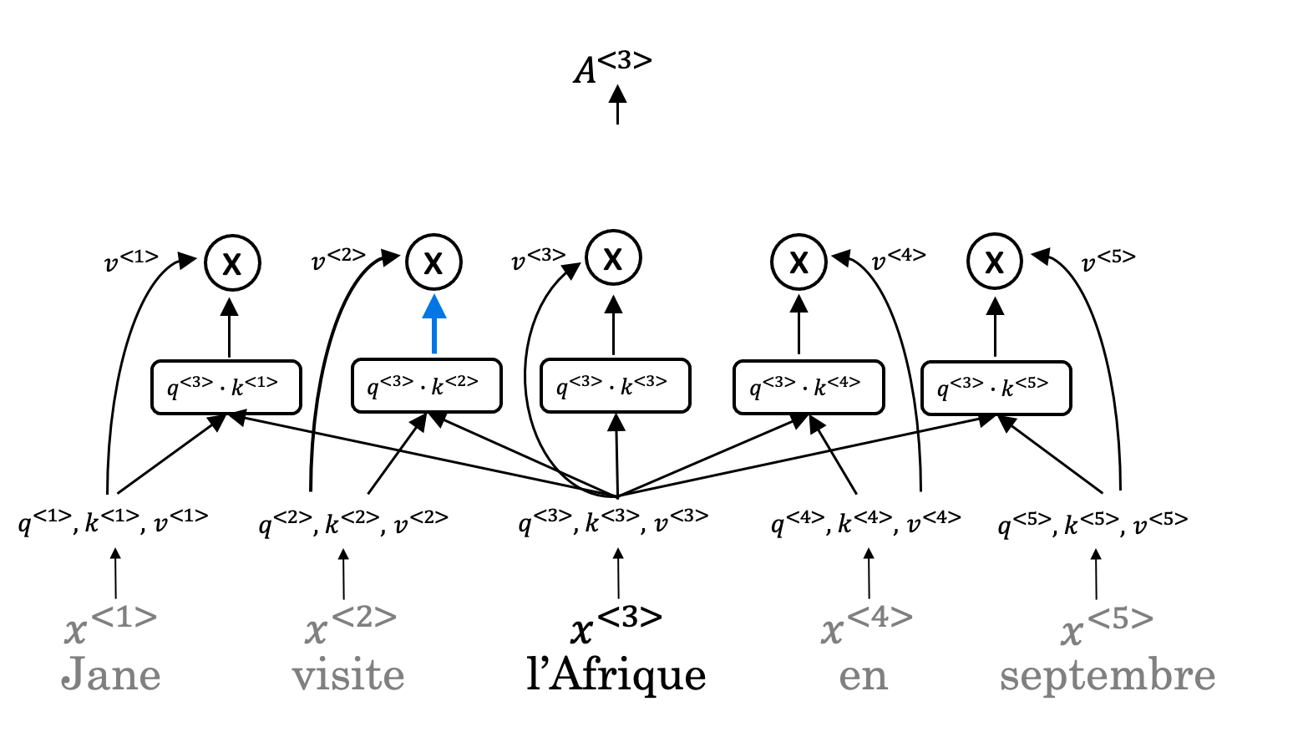
Given a word, its neighbouring words are used to compute its context by summing up the word values to map the Attention related to that given word.
Nice work
1 / 1 point

Question 4
What letter does the "$?$question mark" represent in the following representation of Attention?
$$Attention(Q,K,V)=softmax(\frac{QK^{T}}{\sqrt{d_{?}}})$$
k
Nice work
k is represented by the $?$question mark in the representation.
1 / 1 point

Question 5
Which of the following statements represents Key (K) as used in the self-attention calculation?
K = qualities of words given a Q
Nice work
The qualities of words given a Q are represented by Key (K).
1 / 1 point

Question 6
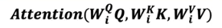
What does $i$i represent in this multi-head attention computation?
The computed attention weight matrix associated with the ith “head” (sequence)
The computed attention weight matrix associated with specific representations of words given a Q
The computed attention weight matrix associated with the order of the words in a sentence
The computed attention weight matrix associated with the ith “word” in a sentence.
Try again
To revise the concept watch the lecture Multi-Head Attention.
0 / 1 point

Question 7
Following is the architecture within a Transformer Network (without displaying positional encoding and output layers(s)).
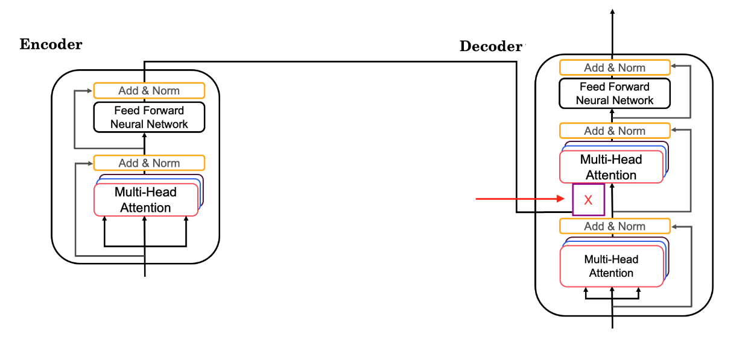
What information does the Decodertake from the Encoder for its second block of Multi-HeadAttention ? (Marked $X$X, pointed by the independent arrow)
(Check all that apply)

K
Nice work
V
Nice work
1 / 1 point

Question 8
Following is the architecture within a Transformer Network (without displaying positional encoding and output layers(s)).
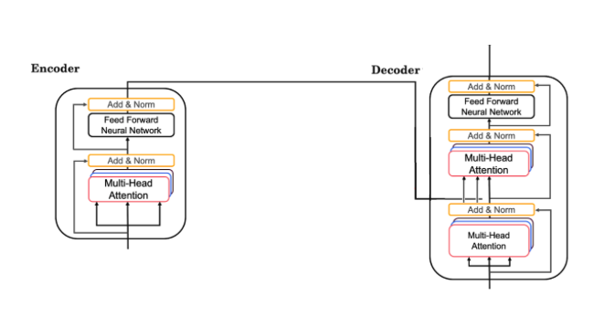
The output of the decoder block contains a softmax layer followed by a linear layer to predict the next word one word at a time.
False

Nice work
The output of the decoder block contains a linear layer followed by a softmax layer to predict the next word one word at a time.
1 / 1 point

Question 9
Which of the following statements is true?
The transformer network differs from the attention model in that only the transformer network contains positional encoding.
Nice work
Positional encoding allows the transformer network to offer an additional benefit over the attention model.
1 / 1 point

Question 10
Which of these is not a good criterion for a good positional encoding algorithm?
It should output a common encoding for each time-step (word’s position in a sentence).
Nice work
This is not a good criterion for a good positional encoding algorithm.

REFERENCES:

Week 1:
- Minimal character-level language model with a Vanilla Recurrent Neural Network, in Python/numpy (GitHub: karpathy)
- The Unreasonable Effectiveness of Recurrent Neural Networks (Andrej Karpathy blog, 2015)
- deepjazz (GitHub: jisungk)
- Learning Jazz Grammars (Gillick, Tang & Keller, 2010)
- A Grammatical Approach to Automatic Improvisation (Keller & Morrison, 2007)
- Surprising Harmonies (Pachet, 1999)

Week 2:
- Man is to Computer Programmer as Woman is to Homemaker? Debiasing Word Embeddings (Bolukbasi, Chang, Zou, Saligrama & Kalai, 2016)
- GloVe: Global Vectors for Word Representation (Pennington, Socher & Manning, 2014)
- Woebot.

Week 4:
- Natural Language Processing Specialization (by DeepLearning.AI)
- Attention Is All You Need (Vaswani, Shazeer, Parmar, Uszkoreit, Jones, Gomez, Kaiser & Polosukhin, 2017)

